EXPERIMENT – 24.

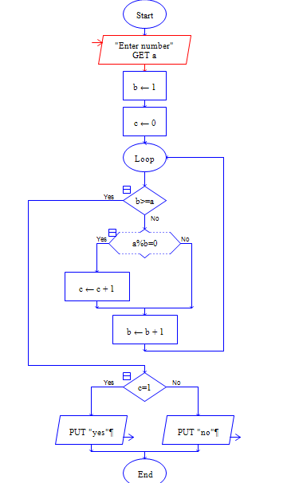

Output:

